## Certificate Import Script (CertProcessor)

The certprocessor and subscripts are created for automating some phases of bulk certificate import.

* CertProcessor script has the following processing steps:

1. Collects the certificates from a given directory,
2. Checks certificate format, and removes BOM from the certificates which are utf8 with bom.
3. Uploads the certificate files to datapower, to the given domain
4. Creates certificate objects on datapower
5. Adds certificate objects to the given Crypto validation credential

* CertProcessor folders, subscripts and their functions are given below:

CertProcessor directory:

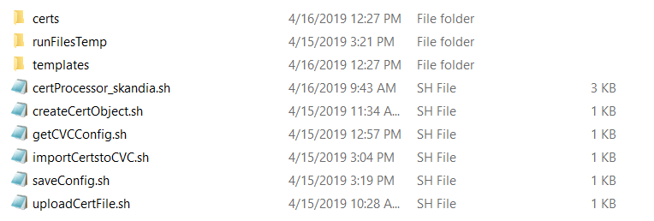

Templates directory:

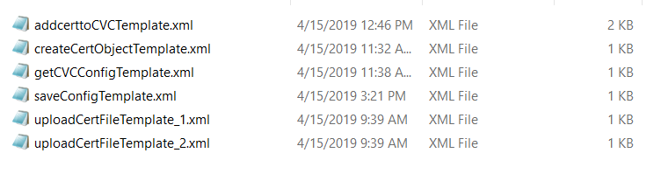

**certProcessor.sh:** Main script. This is the only script to be run by the admin to import certificates. All other scripts and files are used and referenced from this main script.

usage: ./certProcessor.sh domainName CVCName certDirectory

**certs:** Folder containing the certificates to be imported. This is not a static folder. Folder name should be given to the main script. Spaces and language specific special characters are not allowed for certificate names. Unix/linux file naming standards should be considered.

**runFilesTemp:** Location for the temporary files, which will be created and deleted by the main script and subscripts. Make sure it’s empty before running the main script.

**Templates:** The folder contains the static xml templates, which will be used by main script and subscripts to do operations on datapower. No modification should be made on the files.

**uploadCertFile.sh**: Subscript to upload certificates to datapower.

**createCertObject.sh:** Subscript to create certificate objects in datapower.

**getCVCConfig.sh:**  Subscript to get the given Crypto Validation Credential object configuration to an xml file on runFilesTemp. The name of the export file, and the import file template will be given as the output of this script.

**importCertstoCVC.sh:** Subscript to add the certificates to the Crypto validation credential. Before this process, some manual operations required, such as to get the list of certificates and merge those to the exported crypto validation credential, and add the merged xml to the import xml file. Main script will guide to the user for this manual operations.

**saveConfig.sh:** Subscript to save and persist the modifications on datapower appliance.